YOUTH VISION INDIA
Women & Legal Awareness Department
Research Paper Series – 02
Women Entrepreneurs in India:
Current Status, Challenges, Government Initiatives and Future Prospects
Author
Jagriti Sharma
Department Head
Women & Legal Awareness Department
Youth Vision India

Executive Summary
Women's entrepreneurship in India has expanded rapidly over the past five years, driven by the formalisation push under the Udyam Registration Portal, targeted credit schemes, and a growing recognition that women-led enterprises are central to India's MSME economy — a sector contributing roughly 30% of GDP, 35% of manufacturing output, and around half of national exports. Women now own approximately 20.5% of all formally registered MSMEs and, remarkably, over 70% of informally registered micro enterprises, revealing both real progress and a persistent 'formalisation gap'.
Government credit schemes show strong, sometimes striking, participation by women: 68% of Pradhan Mantri Mudra Yojana (PMMY) beneficiaries and 84% of Stand-Up India loans go to women entrepreneurs. Yet women-owned enterprises remain smaller in scale — accounting for only around one in ten rupees of MSME investment and turnover — and are disproportionately represented among business closures, with over 24,000 women-led MSME shutdowns recorded in a recent five-year period.
This paper argues that India's policy priority must now shift from credit access — where progress has been genuinely strong — to scale, formalisation, and survival. It examines four major schemes (Stand-Up India, PMMY, PMEGP, and the Yashasvini Campaign), highlights sharp state-level variation, and identifies five structural barriers ranging from collateral requirements to unpaid care work. It closes by outlining a practical role for youth-led organisations such as Youth Vision India in mentorship, digital literacy, and market linkage for women entrepreneurs.
Key figures at a glance:
- Women-owned share of formally registered MSMEs: 20.5% (Udyam Registration Portal)
- Women-owned share of informal micro enterprises: ~70.5% (Udyam Assist Platform)
- Women's share of PMMY (Mudra) beneficiaries: 68%; Stand-Up India: 84%
- Women-led MSME closures: over 24,000 units, ~1.6 lakh jobs lost (recent 5-year period)

Table of Contents

Women Entrepreneurs in India: Current Status, Challenges, Government Initiatives and Future Prospects

Abstract
Women's entrepreneurship is increasingly recognised as a central pillar of India's economic growth strategy, offering a pathway to financial independence, employment generation, and household-level empowerment. India's Micro, Small and Medium Enterprises (MSME) sector — contributing nearly a third of national GDP and around half of exports — has become a critical arena for this transformation. According to the Ministry of MSME's Udyam Registration Portal, women-owned enterprises constitute approximately 20.5% of all formally registered MSMEs, contributing 18.73% of sector employment, while women own more than 70% of informal micro enterprises registered on the Udyam Assist Platform (Ministry of Micro, Small & Medium Enterprises, 2025).
Government credit schemes have shown notable success in reaching women: 68% of Pradhan Mantri Mudra Yojana beneficiaries and 84% of Stand-Up India loans are sanctioned to women entrepreneurs (Ministry of Finance, 2025). Yet women-led enterprises remain concentrated in micro and informal segments, face disproportionate rates of business closure, and continue to encounter barriers in collateral, market access, and unpaid domestic responsibilities.
This paper critically examines the current status of women's entrepreneurship in India, evaluating major government interventions — Stand-Up India, Pradhan Mantri Mudra Yojana, the Prime Minister's Employment Generation Programme (PMEGP), and the Yashasvini Campaign — alongside state-wise disparities and structural barriers to growth. The study argues that policy attention must now shift from expanding credit access, where results have been strong, to addressing the formalisation gap, enterprise scale, and business survival, positioning women's entrepreneurship as a strategic driver of inclusive economic growth rather than a welfare category.

Keywords
Women Entrepreneurs; India; MSME; Udyam Registration; Financial Inclusion; Stand-Up India; Mudra Yojana; Women's Economic Empowerment.

1. Introduction
Entrepreneurship has become one of the most direct pathways to economic independence for women in India, offering an alternative to formal wage employment in a labour market where women's workforce participation remains comparatively low. Beyond individual income, women-led enterprises generate employment for other women, strengthen household financial resilience, and — as international evidence consistently shows — tend to reinvest a larger share of earnings into family health and education (International Labour Organization, 2020).
India's Micro, Small and Medium Enterprises (MSME) sector is the natural home of this shift. MSMEs contribute close to one-third of India's GDP, around 35% of manufacturing output, and nearly half of the country's exports, making the sector the second-largest employer in the country after agriculture (Ministry of Micro, Small & Medium Enterprises, 2025). The launch of the Udyam Registration Portal in July 2020 — and the subsequent Udyam Assist Platform for informal enterprises in January 2023 — has, for the first time, given policymakers a reasonably reliable, real-time picture of who owns India's small businesses, including by gender.
That data shows a genuinely two-sided story. On formal registration, women own approximately 20.5% of Udyam-registered MSMEs, contributing 18.73% of employment and 10.22% of turnover generated by the sector (Ministry of Micro, Small & Medium Enterprises, 2025). On the informal side, the picture flips dramatically: women own more than 70% of Informal Micro Enterprises (IMEs) captured on the Udyam Assist Platform. This gap between formal and informal ownership — sometimes called the 'missing middle' — is one of the central themes of this paper.
Government credit schemes have played a significant role in this landscape. As of early 2025, women constituted 68% of all Pradhan Mantri Mudra Yojana (PMMY) beneficiaries and 84% of Stand-Up India loan recipients (Ministry of Finance, 2025). These figures represent one of the more genuinely successful examples of gender-targeted financial inclusion in Indian public policy — though, as this paper discusses, high beneficiary shares in loan count do not automatically translate into equally high shares of loan value, enterprise scale, or business survival.
This paper examines the current status of women's entrepreneurship in India through official Udyam, PMMY, and Stand-Up India data; critically evaluates the major government schemes shaping this landscape; documents state-wise variation; and identifies the structural barriers — financial, social, and institutional — that continue to constrain the scale and survival of women-led enterprises.

2. Research Methodology
This study adopts a qualitative, descriptive, and analytical research design based exclusively on secondary sources of data. The objective is not to generate primary field evidence but to critically evaluate the current status of women's entrepreneurship in India through an examination of official statistics, policy documents, and scholarly literature.
The analysis relies primarily on data released by the Ministry of Micro, Small & Medium Enterprises (Udyam Registration Portal and Udyam Assist Platform), the Ministry of Finance (Pradhan Mantri Mudra Yojana and Stand-Up India performance data), and Lok Sabha replies presenting state-wise figures. Additional evidence has been drawn from reports published by the International Labour Organization, the Press Information Bureau, and relevant government press releases. These sources were selected for their official status, national coverage, and recency.
A thematic analysis approach was employed to classify the collected information into four major domains: current participation, government schemes, state-wise variation, and structural barriers. Rather than presenting statistics in isolation, the study interprets official data in relation to broader questions of financial inclusion, enterprise scale, and gender-responsive policy design.
Since the research is based entirely on publicly available documents, no human participants were involved and no ethical clearance was required. Every effort has been made to ensure that interpretations remain objective, evidence-based, and consistent with recognised academic standards.

3. Current Status of Women Entrepreneurship in India
Women's participation in India's enterprise economy has grown substantially over the past five years, propelled largely by the formalisation drive that followed the revised MSME definition of July 2020. Between July 2020 and November 2025, more than 2.86 crore women-led MSMEs were registered on the Udyam Registration Portal and Udyam Assist Platform combined — a scale of formal recognition that did not previously exist (Ministry of Micro, Small & Medium Enterprises, 2025).
Within the formal Udyam base specifically, women-owned enterprises account for approximately 20.5% of all registered MSMEs, contributing 18.73% of sector employment, 11.15% of investment, and 10.22% of turnover. Notably, 26.2% of proprietary (sole-ownership) MSMEs are now female-led, suggesting particular strength in individually-owned micro businesses (Ministry of Micro, Small & Medium Enterprises, 2025).
The more striking figure lies in the informal sector. On the Udyam Assist Platform — which captures Informal Micro Enterprises (IMEs) not previously part of any formal registry — women own more than 70% of all registered units and contribute a similar share of the employment generated. This means women's economic activity is disproportionately concentrated in the informal, smallest-scale segment of the enterprise economy, even as their formal-sector participation continues to rise (Ministry of Micro, Small & Medium Enterprises, 2024).
This asymmetry — high informal participation but comparatively low formal-sector share, scale, and turnover — is what several analysts term India's women's entrepreneurship 'missing middle': a large base of informal micro-entrepreneurs, a much smaller cohort of formally registered proprietors, and a very thin layer of women-led enterprises that grow into small or medium-sized companies.
Table 1. Selected Indicators of Women's Entrepreneurship in India
Indicator | Latest Status | Source
Women-owned share of formal MSMEs (Udyam) | 20.5% | Ministry of MSME, 2025
Women's share of formal MSME employment | 18.73% | Ministry of MSME, 2025
Women-owned share of informal micro enterprises (UAP) | ~70.5% | Ministry of MSME, 2024
Women-led MSMEs registered, Jul 2020–Nov 2025 | 2.86+ crore | Lok Sabha reply, 2025
Women's share of PMMY (Mudra) beneficiaries | 68% | Ministry of Finance, 2025
Women's share of Stand-Up India loans | 84% | Ministry of Finance, 2023
Source: Ministry of Micro, Small & Medium Enterprises and Ministry of Finance, Government of India (2023–2025).
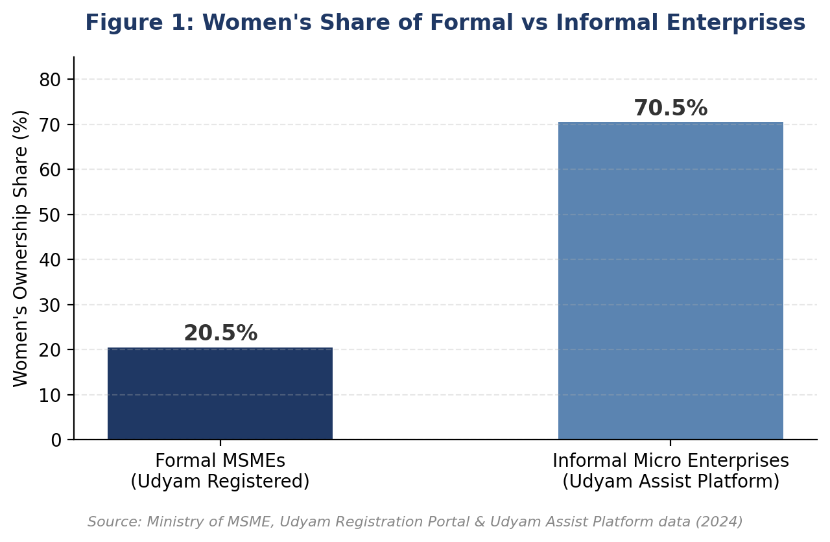

Analytical Interpretation
The data presented above tell a story of genuine, measurable progress alongside a structural imbalance that policy has not yet resolved. Formalisation campaigns and gender-targeted credit schemes have successfully brought millions of women into India's enterprise economy. However, the concentration of women's ownership at the informal, micro end of the spectrum — combined with a disproportionately low share of investment and turnover even within the formal segment — suggests that access alone has not translated into scale. Future policy should therefore evaluate success not only by the number of women-owned enterprises registered, but by their rate of formalisation, growth in scale, and long-term survival.
Key Findings — Current Status
- Women own 20.5% of formally registered MSMEs but over 70% of informal micro enterprises — a significant 'missing middle' gap.
- 26.2% of all proprietary (sole-ownership) MSMEs are now women-led, reflecting rising individual entrepreneurship.
- Women's enterprises contribute disproportionately less to turnover (10.22%) and investment (11.15%) than to employment (18.73%), indicating smaller average enterprise scale.
- Over 2.86 crore women-led MSMEs have been registered since July 2020 — a scale of formal recognition unprecedented in India's MSME history.

4. Government Schemes and Policy Initiatives: A Critical Evaluation
India's policy response to women's entrepreneurship has evolved from small, standalone schemes into an integrated credit and formalisation ecosystem. This section evaluates the four most significant interventions currently shaping the landscape: Stand-Up India, the Pradhan Mantri Mudra Yojana, the Prime Minister's Employment Generation Programme, and the more recent Yashasvini Campaign.

4.1 Stand-Up India
Launched on 5 April 2016, Stand-Up India promotes entrepreneurship among women and SC/ST communities by facilitating bank loans between ₹10 lakh and ₹1 crore for setting up greenfield (first-time) enterprises in manufacturing, services, or trading. As of November 2023, women entrepreneurs received 84% of all Stand-Up India loans sanctioned — 1.77 lakh of 2.09 lakh total loans (Ministry of Finance, 2023).
This is among the most gender-skewed of India's flagship credit schemes, reflecting its explicit design mandate that at least one loan per bank branch go to a woman borrower. Its main limitation is scale: the greenfield, first-time-enterprise requirement and relatively high loan floor (₹10 lakh) make it more suited to formal, scalable ventures than to the informal micro-enterprises where most women entrepreneurs currently operate.

4.2 Pradhan Mantri Mudra Yojana (PMMY)
Launched on 8 April 2015, PMMY provides collateral-free institutional credit of up to ₹20 lakh (revised upward from ₹10 lakh) to non-corporate, non-farm micro and small enterprises, through Shishu, Kishore, Tarun, and Tarun Plus loan categories based on business stage. As of January 2025, cumulative PMMY disbursement crossed ₹32.36 lakh crore across more than 51 crore loans, with women accounting for 68% of all beneficiaries (Ministry of Finance, 2025).
PMMY's strength is reach: its collateral-free design and low entry threshold (loans from ₹50,000) make it accessible to first-generation and informal women entrepreneurs in a way that larger schemes cannot match. Its main limitation is average ticket size — most women borrowers access the smallest 'Shishu' category, which limits the scheme's ability to help enterprises grow beyond micro scale.

4.3 Prime Minister's Employment Generation Programme (PMEGP)
PMEGP offers credit-linked capital subsidies for setting up new micro-enterprises, with women entrepreneurs receiving preferential subsidy rates — 25% in urban areas and 35% in rural areas, compared to lower general rates. As of December 2025, women formed 39% of total PMEGP beneficiaries (Ministry of Micro, Small & Medium Enterprises, 2025).
Compared to PMMY and Stand-Up India, PMEGP's women's share is notably lower, suggesting that despite preferential subsidy rates, awareness or uptake among women entrepreneurs remains comparatively weaker for this particular scheme — an area meriting targeted outreach.

4.4 Yashasvini Campaign and Public Procurement Policy
Launched on 27 June 2024, the Yashasvini Campaign is a more recent, explicitly gender-focused initiative aiming to achieve gender parity on the Udyam Registration Portal by 2029, while raising awareness of the Public Procurement Policy's mandate that at least 3% of annual central government procurement come from women-owned micro and small enterprises. Since its launch, Yashasvini-linked drives have facilitated the registration of over 12.5 lakh additional women-owned MSMEs, including a dedicated campaign in Mizoram that registered around 8,400 women-owned units (Ministry of Micro, Small & Medium Enterprises, 2025).
Unlike PMMY or Stand-Up India, Yashasvini is not primarily a credit scheme but an awareness and formalisation campaign — its contribution lies in closing the registration gap identified in Section 3, rather than in direct lending. Its 2029 gender-parity target gives policymakers a clear, trackable benchmark against which future progress can be measured.
Table 2. Comparative Snapshot of Major Government Schemes
Scheme | Women's Share / Focus | Key Limitation
Stand-Up India | 84% of loans to women (Nov 2023) | High loan floor (₹10 lakh) limits access for micro-enterprises
Pradhan Mantri Mudra Yojana | 68% of beneficiaries are women | Most women borrow in the smallest 'Shishu' category, limiting scale
PMEGP | 39% of beneficiaries are women | Lower uptake among women despite preferential subsidy rates
Yashasvini Campaign | Targets Udyam gender parity by 2029 | Awareness-driven; not a direct credit or subsidy instrument
Source: Ministry of Finance and Ministry of Micro, Small & Medium Enterprises, Government of India (2023–2025).
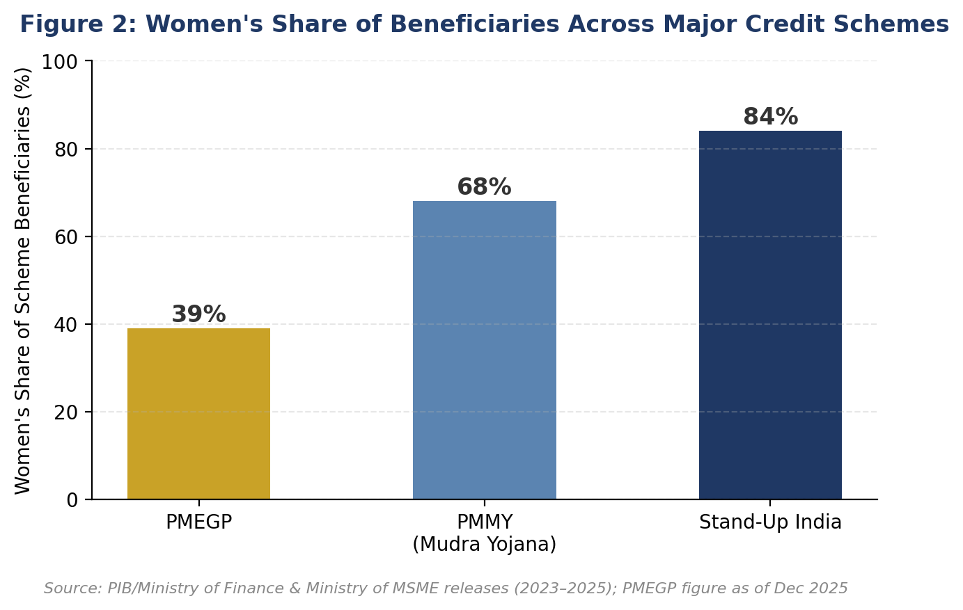

Synthesis
Across all four schemes, women's participation in credit access is genuinely strong by international standards — a fact that deserves recognition rather than being overshadowed by the scale challenges discussed elsewhere in this paper. The recurring pattern, however, is that women's participation is highest in the smallest, most collateral-free instruments (PMMY, Stand-Up India) and comparatively lower in schemes requiring more formal engagement (PMEGP). This suggests that reducing procedural and collateral barriers — not just announcing new schemes — is what drives genuine uptake.
Key Findings — Government Schemes
- Women's share of beneficiaries is highest in the most accessible, collateral-free schemes (Stand-Up India: 84%; PMMY: 68%).
- PMEGP's comparatively lower women's share (39%) suggests an awareness or procedural gap despite preferential subsidy rates.
- The Yashasvini Campaign (2024) is the first scheme to set an explicit, trackable gender-parity target (2029) for Udyam registration.
- The common constraint across schemes is enterprise scale: women-led businesses access credit but remain concentrated in the smallest loan categories.

5. State-Wise Disparities in Women's Entrepreneurship
National averages conceal considerable variation in where women-led enterprises are concentrated, both in absolute numbers and as a share of each state's total MSME base. Industrially advanced states host the largest absolute numbers of women-led MSMEs, while several other states show faster relative growth or distinct, non-Udyam models of women's economic organisation.
As of late 2025, Maharashtra hosts the largest number of women-led MSMEs in the country at over 33.5 lakh units, followed by West Bengal (28.47 lakh) and Tamil Nadu (25.5 lakh) (Ministry of Micro, Small & Medium Enterprises, 2025). Madhya Pradesh presents a different kind of story: while its absolute base is smaller, women now own roughly 25.8% of the state's total registered MSMEs — up from a base of just 14,239 women-owned units in 2020 to 2,28,959 by February 2026, alongside a six-fold rise in women's MSME employment over the same period (data tabled in the Lok Sabha, 2026).
Table 3. Women-Led MSMEs: Selected State Highlights
State | Women-Led MSMEs / Share | Observation
Maharashtra | 33.5 lakh (highest in India) | Largest overall MSME base; broad-based growth
West Bengal | 28.47 lakh | One study found the highest female ownership share (~23%) among major states
Tamil Nadu | 25.5 lakh | Strong manufacturing-linked women's enterprises
Madhya Pradesh | 2.29 lakh (~25.8% of state MSMEs) | Fastest-growing women's ownership share; 16-fold rise since 2020
Andhra Pradesh | Reported by one Lok Sabha data-point as highest count nationally | Conflicts with Maharashtra-led figures; requires verification before citing precisely
Kerala | Smaller formal MSME base | Home to Kudumbashree, India's largest women's SHG network (~46 lakh members)
Source: Ministry of MSME / Lok Sabha replies (2025–2026); Kudumbashree figures from Government of Kerala / Wikipedia (2025).
Note: State-wise women-led MSME figures come from different Parliamentary replies and dates, and are not always fully reconcilable with one another (for instance, one 2026 report describes Andhra Pradesh as having the highest count of women-owned enterprises nationally, which conflicts with Maharashtra-led figures from a 2025 reply). Readers requiring precise, citable figures should consult the original Lok Sabha reply or Udyam dashboard for the relevant date.
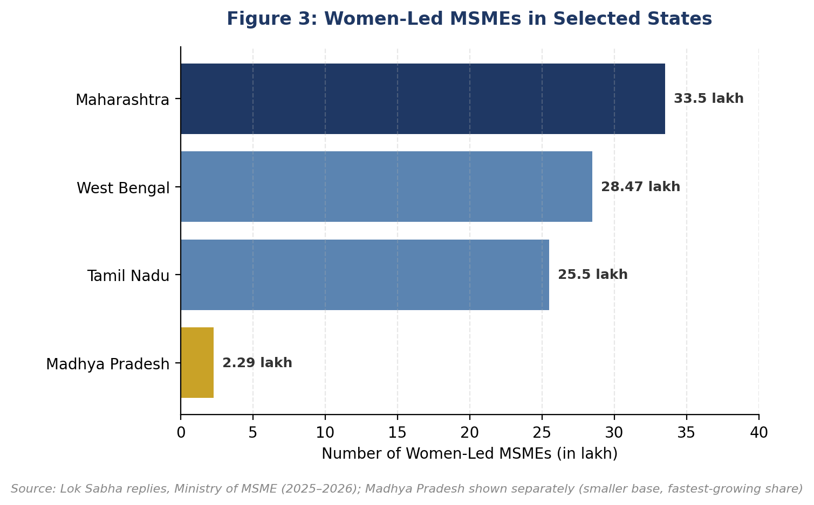

Why This Matters for Policy
Kerala's case is particularly instructive: despite a comparatively small formal Udyam base, the state is home to Kudumbashree, India's largest women's self-help group network, with roughly 46 lakh members organised through neighbourhood groups and Community Development Societies (Government of Kerala, 2025). This suggests that Udyam registration data alone can understate a state's true level of women's economic organisation where alternative, community-based institutional models are strong — a caution relevant to any state-wise policy comparison.
Key Findings — State-Wise Disparities
- Maharashtra, West Bengal, and Tamil Nadu together host the largest absolute numbers of women-led MSMEs.
- Madhya Pradesh shows the fastest relative growth in women's MSME ownership share, rising roughly 16-fold since 2020.
- State-wise data from different official sources is not always reconcilable — comparisons should be treated as indicative, not precise rankings.
- Kerala's Kudumbashree network (~46 lakh women) shows that Udyam data alone can understate a state's true women's economic participation.

6. Structural Challenges Facing Women Entrepreneurs in India
Although participation and credit-access indicators have improved substantially, women entrepreneurs in India continue to face a set of interlocking structural barriers that limit the scale, formalisation, and survival of their enterprises. These barriers span financial, social, and institutional dimensions, and — as in girls' education — they often compound one another rather than operating in isolation.

6.1 Access to Formal Credit and Collateral Barriers
Despite strong beneficiary shares under PMMY and Stand-Up India, women entrepreneurs report persistent difficulty accessing credit beyond the smallest loan categories. Broader MSME sector data shows that only around 6.3% of non-food commercial bank credit reaches the MSME sector as a whole (FY24), and within that already-constrained pool, women-led enterprises — smaller on average and more likely to lack formal collateral or credit history — face additional friction (FIDC India, 2024).
Addressing this requires moving beyond loan-count targets towards tracking loan value, graduation rates from micro to small enterprise categories, and time-to-approval for women borrowers specifically.

6.2 Informality and the 'Missing Middle'
As shown in Section 3, women own over 70% of informal micro enterprises but only 20.5% of formally registered MSMEs. This gap matters because formal registration is a gateway to institutional credit, government procurement, and scheme benefits — an unregistered enterprise, however successful, remains largely invisible to policy support.
Recent SIDBI survey data suggests that around 35% of all MSMEs remain unregistered nationally, primarily due to lack of awareness or fear of regulatory scrutiny (SIDBI, 2025) — a barrier likely to affect women-led enterprises disproportionately, given lower average digital and financial literacy in the segments where women's informal entrepreneurship is concentrated.

6.3 Social and Cultural Constraints
Unpaid domestic and care work continues to fall disproportionately on women, limiting the time and mobility available for business development, market visits, and networking. Social expectations around women's public visibility, especially in rural and semi-urban areas, further constrain access to markets, trade fairs, and business associations that are often central to enterprise growth.
These constraints are rarely captured in credit or registration statistics, but they shape which women can convert access to formal schemes into a scalable, sustainable enterprise.

6.4 Digital and Market Access Gap
Digital literacy and e-commerce participation increasingly determine which enterprises can access markets beyond their immediate locality. Women entrepreneurs — particularly first-generation and rural entrepreneurs — report lower comfort with digital registration, online marketplaces, and digital payment systems, compounding the barriers already discussed in this paper's companion study on girls' education.

6.5 Business Survival and Sustainability
Perhaps the most concerning recent finding is that women-led MSME closures have themselves become a significant policy issue: over 24,000 women-led MSMEs closed in a recent multi-year period, eliminating more than 1.6 lakh jobs, with the largest numbers of closures concentrated precisely in the states with the largest numbers of women-led enterprises — Maharashtra, Tamil Nadu, Gujarat, and Karnataka (Ministry of Micro, Small & Medium Enterprises, 2025).
This finding reframes the policy challenge: it is not only about starting more women-led enterprises, but about ensuring the enterprises that do start are able to survive and grow, through better working-capital access, market linkages, and business mentorship in the crucial early years.
Table 4. Structural Challenges and Their Implications
Challenge | Impact on Women Entrepreneurs | Policy Priority
Collateral and credit-scale barriers | Difficulty growing beyond micro-loan categories | Track loan value and graduation rates, not just beneficiary count
Informality ('missing middle') | Limited access to procurement and scheme benefits | Simplify Udyam registration; targeted formalisation drives
Unpaid care work and mobility limits | Reduced time for market development and networking | Childcare support and flexible scheme delivery models
Digital and market access gap | Limited reach beyond local markets | Digital literacy and e-commerce onboarding support
Business survival and sustainability | Disproportionate share of MSME closures | Working-capital support and post-launch mentorship programmes
Source: Compiled by the author, synthesising Ministry of MSME, SIDBI, and FIDC India reporting (2024–2025).

Critical Discussion
The evidence in this section indicates that India's women's entrepreneurship challenge has entered a second phase. The first phase — getting women into the enterprise economy at all — has been addressed with real success through Udyam formalisation drives and gender-targeted credit schemes. The second, harder phase is ensuring those enterprises can scale, formalise, and survive. This requires policy attention to shift from access metrics towards quality metrics: enterprise growth, credit-to-turnover ratios, and business survival rates disaggregated by gender.
Key Findings — Structural Challenges
- Five interlocking barriers persist: credit-scale limits, informality, unpaid care work, the digital divide, and weak business survival.
- Only ~6.3% of non-food commercial credit reaches the MSME sector overall, constraining even well-performing women-led enterprises.
- Women-led MSME closures (24,000+ units, 1.6 lakh jobs) are concentrated in the very states with the largest women-led enterprise bases.
- The policy shift required is from access-based metrics to survival- and scale-based metrics.

7. From Policy to Practice: The Role of Youth, Communities and Institutions
As with girls' education, government schemes alone cannot close the scale and survival gaps identified in this paper. Sustainable change requires active participation from educational institutions, financial institutions, civil society organisations, youth volunteers, and local communities working alongside — not merely downstream of — government programmes.

7.1 Role of Youth
Young people, particularly those with digital fluency, are well positioned to help women entrepreneurs bridge the digital and market-access gaps identified in Section 6. Peer mentorship, social media and e-commerce onboarding support, and youth-led business plan workshops can meaningfully complement formal credit schemes.

7.2 Role of Youth Vision India
Youth Vision India (YVI) can extend its existing Women & Legal Awareness Department mandate to support women entrepreneurs through practical, low-cost interventions that address the specific barriers identified in this paper.
Some practical initiatives include:
- Launching a volunteer-led “Digital Udyam” programme to help informal women entrepreneurs complete Udyam and Udyam Assist registration.
- Organising scheme-awareness sessions on PMMY, Stand-Up India, and PMEGP eligibility and application processes.
- Conducting digital literacy and e-commerce onboarding workshops for women-led micro enterprises.
- Creating legal awareness modules on business registration, contracts, and consumer protection for women entrepreneurs.
- Developing a mentorship fellowship pairing established women entrepreneurs with first-generation founders.
- Publishing evidence-based policy briefs tracking state-wise women's MSME data.
- Building partnerships with banks, NBFCs, and district industries centres to improve credit-scheme awareness.
These initiatives require limited financial resources but can generate long-term entrepreneurial and social impact, particularly if targeted at the informal, first-generation entrepreneurs who remain furthest from formal credit systems.

7.3 Role of Financial and Educational Institutions
Banks, NBFCs, and microfinance institutions should move beyond loan disbursement to offer structured post-loan mentorship, business literacy training, and market-linkage support. Educational institutions, similarly, can integrate entrepreneurship modules — including scheme awareness and digital business skills — into vocational and higher-education curricula for young women.

7.4 Community Participation
Community-based institutional models — most notably Kerala's Kudumbashree — demonstrate that peer-support networks can be as important as formal credit access in sustaining women's entrepreneurship. Self-help groups, alumni networks, and local business associations should be encouraged and, where possible, linked formally to Udyam registration and government scheme outreach.

Author's Perspective
Women's entrepreneurship should not be measured only by how many women start businesses, but by how many are able to grow, formalise, and sustain them across economic cycles. The real test of India's entrepreneurship policy over the next decade will not be registration numbers — which have already grown impressively — but whether the enterprises being registered today are still operating, and growing, five years from now.

8. Conclusion
India has made genuine, measurable progress in bringing women into its enterprise economy. Formalisation drives have registered over 2.86 crore women-led MSMEs since 2020, and credit schemes such as PMMY and Stand-Up India show gender-participation rates that compare favourably with international benchmarks. These are not small achievements, and they deserve recognition alongside the challenges this paper documents.
At the same time, the evidence points clearly to a second, harder policy phase: closing the formalisation gap between women's dominant informal presence and comparatively modest formal-sector share; helping micro-enterprises scale beyond the smallest loan categories; and addressing the disproportionate rate of business closure among women-led enterprises.
For organisations such as Youth Vision India, the opportunity lies in practical, ground-level interventions — digital literacy, scheme navigation support, and mentorship — that can help convert India's strong credit-access numbers into durable, growing, women-led businesses.
Ultimately, supporting women's entrepreneurship is not a welfare measure — it is an investment in India's economic base. A nation that helps its women-led enterprises formalise, scale, and survive strengthens its GDP, its exports, and the economic security of millions of households simultaneously.

9. Future Scope of Research
While this paper has examined the present status of women's entrepreneurship in India through policy analysis and secondary data, several areas require deeper academic investigation. Future research may explore the specific drivers behind women-led MSME closures, sector-wise variation in women's entrepreneurship (manufacturing versus services versus retail), the comparative effectiveness of SHG-based models such as Kudumbashree versus individual Udyam registration, and the long-term graduation rates of women-led enterprises from micro to small and medium scale.
Further research should increasingly adopt mixed-method approaches, combining Udyam and scheme-level quantitative data with qualitative evidence from women entrepreneurs themselves, particularly in the informal sector where official data remains thinnest.

10. Limitations of the Study
This study is based entirely on secondary sources of information, including official government reports, Lok Sabha replies, and publications of recognised financial institutions. Since no primary field survey or interviews were conducted, the findings should be interpreted within the scope of available published evidence.
Furthermore, as noted in Section 5, state-wise figures drawn from different Parliamentary replies and dates are not always fully reconcilable, and enterprise indicators continue to evolve with newly released Udyam data; future studies should update statistical analysis using the latest official reports.

Data Verification Note
All statistics in this paper are drawn from cited government and institutional sources current as of 2023–2025 (principally Ministry of MSME Udyam data, Ministry of Finance PMMY/Stand-Up India releases, and Lok Sabha replies through early 2026). Before this paper is published, presented, or cited externally, the author recommends re-verifying every statistic, table, and figure against the latest available official release from the Ministry of MSME, Ministry of Finance, and the Udyam Registration dashboard, given how rapidly these registration figures continue to change.

11. Final Reflection
Women's entrepreneurship in India is often discussed through registration counts, loan disbursement figures, and scheme names. However, behind every statistic in this paper is a woman who chose to formalise a small business, apply for a first loan, or register an enterprise that had, until then, existed only informally. Economic equality is not achieved merely by making credit available — it is achieved when every woman who starts a business has a realistic path to growing, sustaining, and scaling it.
India has already demonstrated that targeted credit design and formalisation campaigns can shift participation at a genuinely national scale. The next challenge is to ensure that access translates into durable enterprises — into jobs that outlast a single loan cycle, and into businesses that grow rather than merely survive.
The responsibility for achieving this vision extends beyond government schemes. Financial institutions, educational bodies, civil society organisations, and youth volunteers all have a shared role in creating an environment where women entrepreneurs are supported not just to register a business, but to build one that lasts.
For organisations such as Youth Vision India, the opportunity lies in transforming awareness into measurable, ground-level action — one registration helped, one mentorship conversation held, one market linkage made at a time.
“When a woman builds a business, she builds a livelihood; when millions of women build businesses, they build a nation's economy.”

Acknowledgement
The author gratefully acknowledges Youth Vision India for providing a platform that encourages youth-led research, public policy discussions, and community engagement. The organisation's commitment to women's economic empowerment, constitutional awareness, and social responsibility has inspired the preparation of this research paper.
The author also acknowledges the Government of India, the Ministry of Micro, Small & Medium Enterprises, the Ministry of Finance, and other institutions whose publicly available reports and datasets have supported evidence-based academic analysis.

References (APA 7th Edition)
Government Reports
1. Ministry of Micro, Small & Medium Enterprises. (2025). Year End Review 2025: Ministry of Micro, Small & Medium Enterprises. Government of India.
2. Ministry of Micro, Small & Medium Enterprises. (2025). Performance of Women-Led MSMEs on Udyam and Udyam Assist Portals. Press Information Bureau, Government of India.
3. Ministry of Micro, Small & Medium Enterprises. (2024). Women Owned MSMEs: State/UT-Wise Registration Data. Press Information Bureau, Government of India.
4. Ministry of Finance, Department of Financial Services. (2025, April 14). Performance Update: Pradhan Mantri Mudra Yojana (PMMY). Press Information Bureau, Government of India.
5. Ministry of Finance, Department of Financial Services. (2023, November 24). Loans Sanctioned Under PMMY and Stand-Up India. Press Information Bureau, Government of India.
6. Government of Kerala, Local Self Government Department. (2025). Kudumbashree Mission: 25th Anniversary Report.
7. Small Industries Development Bank of India. (2025). MSME Formalisation Survey 2025.
Institutional and Academic Reports
1. FIDC India. (2024). MSME Sampark 2.0 Report.
2. International Labour Organization. (2020). Empowering Women in the Informal Economy: Challenges and Opportunities.
3. SME Venture. (2026). Women-Led MSMEs Now Form 39% of India's Registered Base.
4. Department for Promotion of Industry and Internal Trade. (2020). Analysis of Udyam Registration Data.
Legal and Constitutional Sources
1. Constitution of India.
2. Micro, Small and Medium Enterprises Development Act, 2006.
3. Public Procurement Policy for Micro and Small Enterprises (MSEs) Order, 2012.

Author's Declaration
This research paper is an original academic work prepared for educational and policy discussion purposes. The analysis is based on publicly available secondary sources, official government publications, and reports of recognised national and international organisations. Every effort has been made to maintain academic integrity, objectivity, and proper attribution of information through APA-style referencing.

